**2. ReactJS – HOL**

**Objectives**

* **Explain React components**

React components are **independent, reusable blocks** of UI built using JavaScript functions or classes. Each component returns a piece of JSX that gets rendered to the DOM.

* **Identify the differences between components and JavaScript functions**

| **Feature** | **JavaScript Function** | **React Component** |
| --- | --- | --- |
| Purpose | Performs logic or computation | Returns UI (JSX) for rendering |
| Return Type | Returns any data type | Must return JSX or null |
| Naming Convention | Can be any name | Must start with a capital letter |
| JSX Usage | Not applicable | JSX used inside return |

* **Identify the types of components**

1. Class Component
2. Function Component

* **Explain Class Component**

1. Uses ES6 class syntax
2. Inherits from **React.Component**
3. Has lifecycle methods like **constructor(),** **componentDidMount()**
4. Uses **render()** method to return JSX

* **Explain Function Component**

1. A simpler component declared using a function
2. Can use React Hooks for state and side effects
3. Cleaner and easier for most use cases

* **Define Component Constructor**

A **constructor** in a class component is used to initialize state and bind methods.

constructor(props) {

super(props);

this.state = {};

}

* **Define render() function**

1. A method inside class components that **returns JSX** (UI code).
2. Must be present in every class component.

**EXERCISE – 2:** Create a Student Management App

Step 1: Open **VS Code**

Step 2: Create a New React App

**npx create-react-app StudentApp**

step 3: Navigate into the project folder

**cd StudentApp**

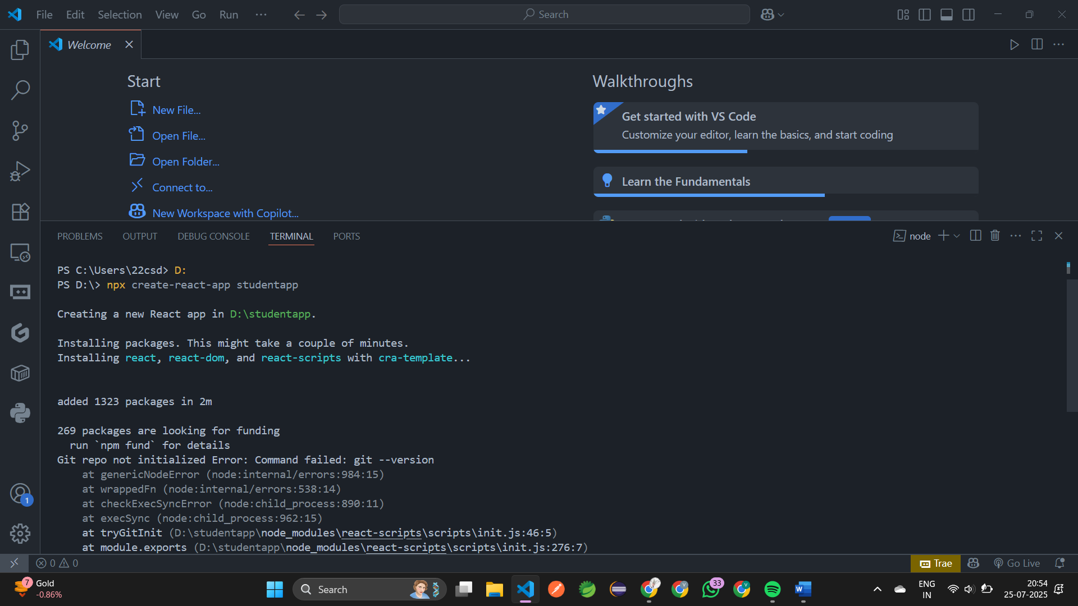

step 4: Create Components folder inside src

**mkdir src/Components**

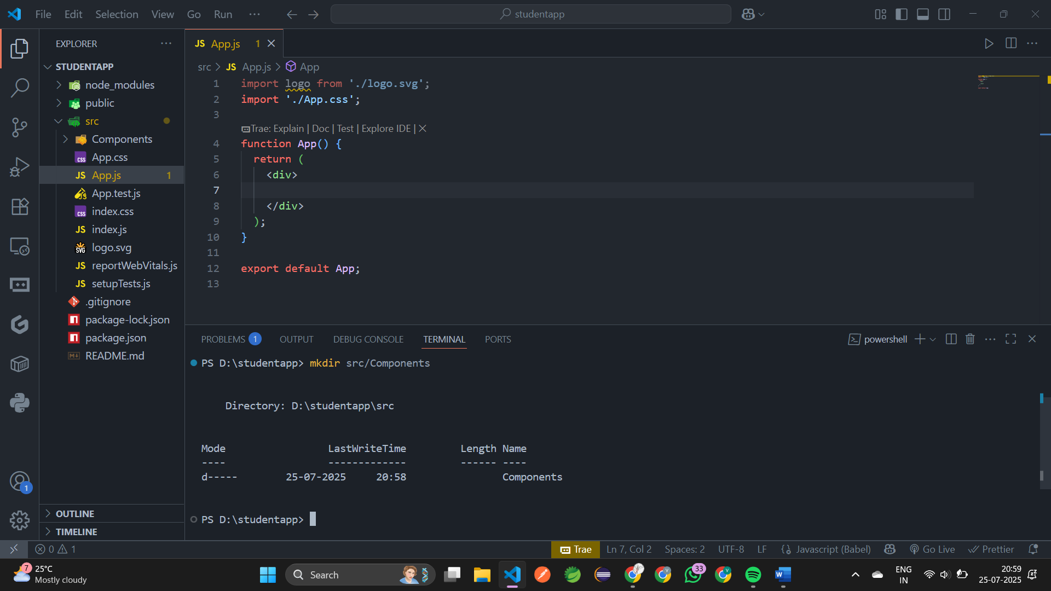

step 5: Inside **src/Components**, create **Home.js**

import React from "react";

function Home(){

    return(

        <div>

            <h2>Welcome to the Home page of Student Management Portal</h2>

        </div>

    );

}

export default Home;

step 6: Create **About.js** in **src/Components**

import React from "react";

function About(){

    return(

        <div>

            <h2>Welcome to the About page of the Student Management Portal

</h2>        </div>

    );

}

export default About;

step 7: Create **Contact.js** in **src/Components**

import React from "react";

function Contact(){

    return(

        <div>

            <h2>Welcome to the Contact page of the Student Management Portal</h2>

        </div>

    );

}

export default Contact;

step 8: Open **src/App.js** and modify it

import './App.css';

import Home from "./Components/Home";

import About from "./Components/About";

import Contact from "./Components/Contact";

function App() {

  return (

    <div className='App'>

      <Home/>

      <About/>

      <Contact/>

    </div>

  );

}

export default App;

step 7: Run the App using **npm start**

Url: <http://localhost:3000>

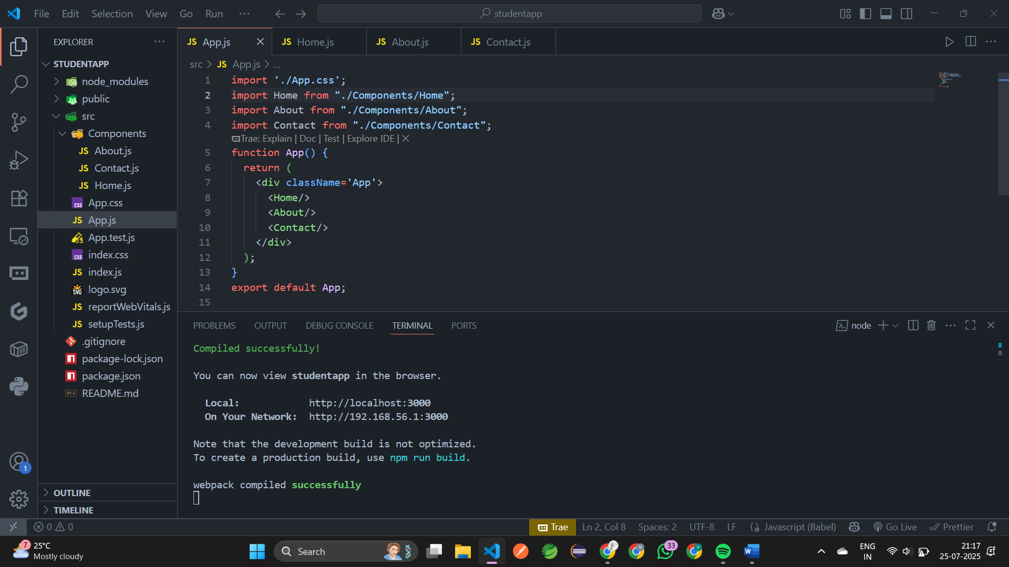

**Output:**

